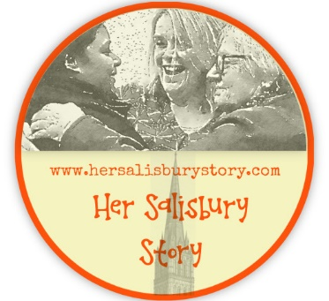
Contemporary Woman Volunteer Expression of Interest

Please tell us about yourself.

Name:

Address:

Email:
Phone:

Which role/s are you interested in volunteering for? (please tick)
Interviewer
Transcriber
Technical support

Why are you interested in becoming an oral history volunteer?

Please tell us about any previous experience you may have of oral history (Experience is not essential)

If you have previous experience of conducting interviews in any setting please tell us about it.

Do you consider yourself to be a fast and accurate typist? (for transcribers)

Have you any experience of editing sound files? If so what?(for tech support)

Are you willing to download free software to work with sound files?
Yes / No / need more information (please mark)

Are you willing to download a free communication platform such as Zoom or Skype?
Yes / No / need more information (please mark)

Please tell us about anything that we need to provide to ensure that you can access any meetings / training (e.g. induction loop, wheelchair ramp, large print)

Please return this form to hersalisburystory@gmail.com
In line with our commitment to equality and diversity we would like to invite you to complete an optional anonymous monitoring form which can be accessed here
https://www.surveymonkey.co.uk/r/KTQVDPV

