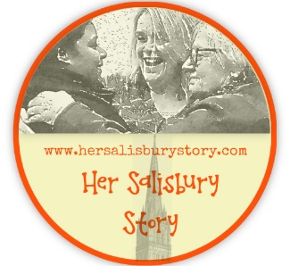
Historical Women Volunteer Expression of Interest

Please tell us about yourself.

Name:

Address:

Email:
Phone:

Why are you interested in becoming a volunteer for the historic women part of the project?

Please tell us about any previous experience you may have of local history research, or any other historical research (This may be family history research, or an educational qualification). Please note: experience is not essential, as training will be provided.

Are you willing to download a free communication platform such as Zoom or Skype?
Yes / No / need more information (please mark)

Please tell us about anything that we need to provide to ensure that you can access any meetings / training (e.g. induction loop, wheelchair ramp, large print)

Please return this form to hersalisburystory@gmail.com
In line with our commitment to equality and diversity we would like to invite you to complete an optional anonymous monitoring form which can be accessed here
https://www.surveymonkey.co.uk/r/KTQVDPV

